Monilochaetes pteridophytophila (Australiascaceae, Glomerellales), a new fungus from tree fern
Jingyi Zhang, Rungtiwa Phookamsak, Ausana Mapook, Yongzhong Lu & Menglan Lv
Supplementary:
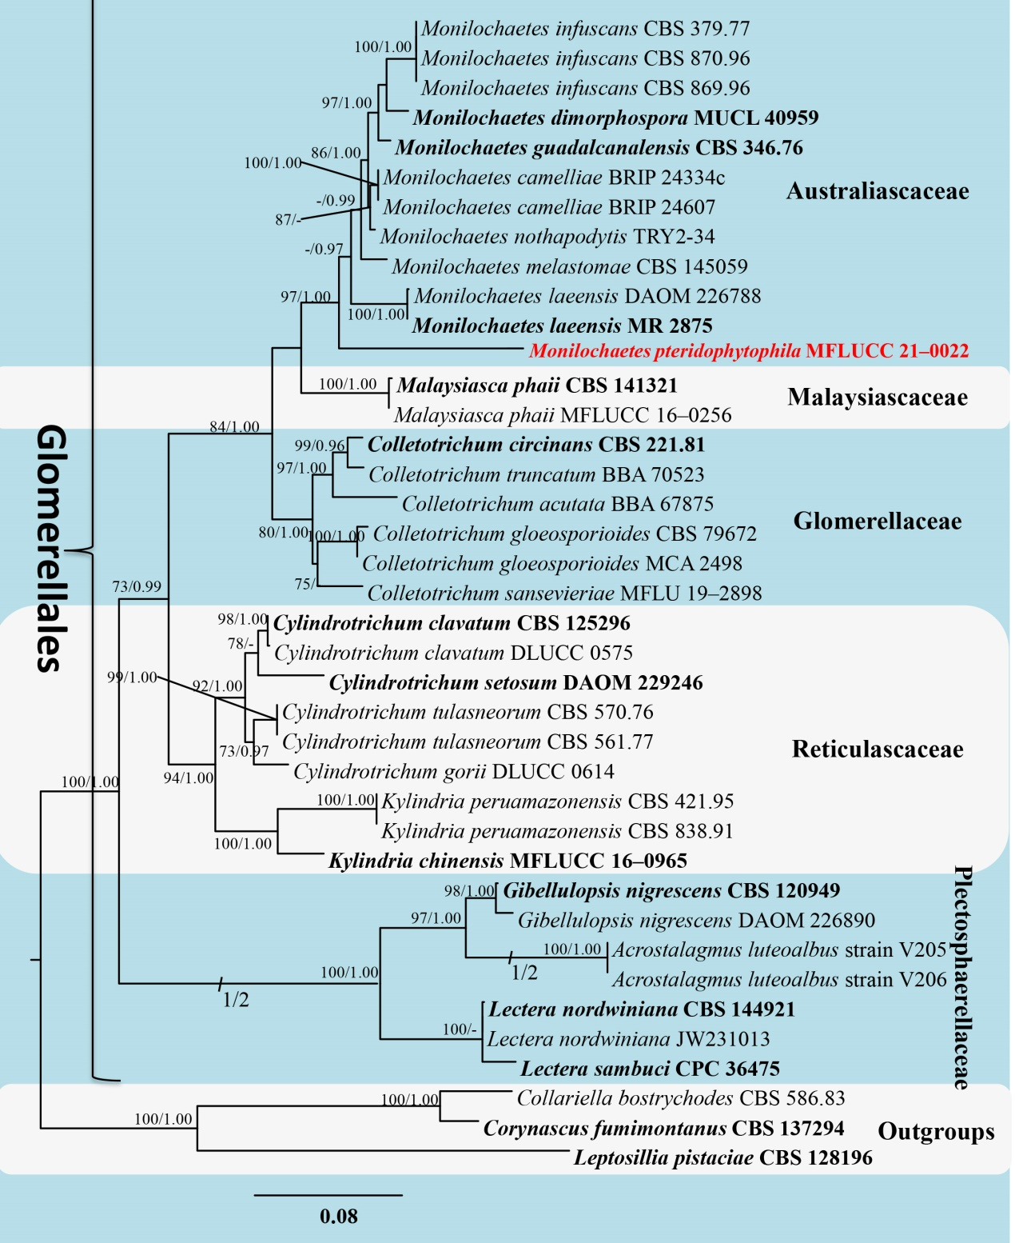

FIGURE S1. Phylogenetic tree generated from maximum likelihood (ML) analysis based on a concatenated LSU-ITS-SSU-RPB2 sequences dataset. Bootstrap values for maximum likelihood equal to or greater than 70% and Bayesian posterior probability equal to or greater than 0.95 PP are indicated at the nodes as MLBS/PP. Hyphen (“-”) indicates a value lower than 70% for MLBS and a posterior probability lower than 0.95 PP for BI analyses. The newly generated strain is shown in red bold. Ex-type strains are indicated by black bold. Collariella bostrychodes (CBS 586.83), Corynascus fumimontanus (CBS 137294) and Leptosillia pistaciae (CBS 128196) are used as outgroup taxa

