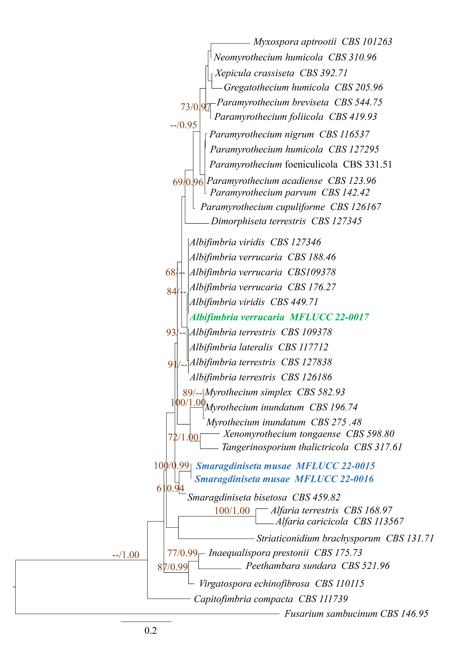

Figure 1. Maximum likelihood tree revealed by RAxML analyses of ITS sequence data of selected genera of Stachybotryaceae, showing the phylogenetic position of Albifimbria verrucaria (MFLUCC 22-0017) and Smaragdiniseta musae (MFLUCC 22-0015, MFLUCC 22-0016). ML bootstrap supports (≥60%) and Bayesian posterior probabilities (≥0.95 BYPP) are given above the nodes, respectively. The tree is rooted with Fusarium sambucinum (CBS146.95) (Nectriaceae). The scale bar represents the expected number of nucleotide substitutions per site.
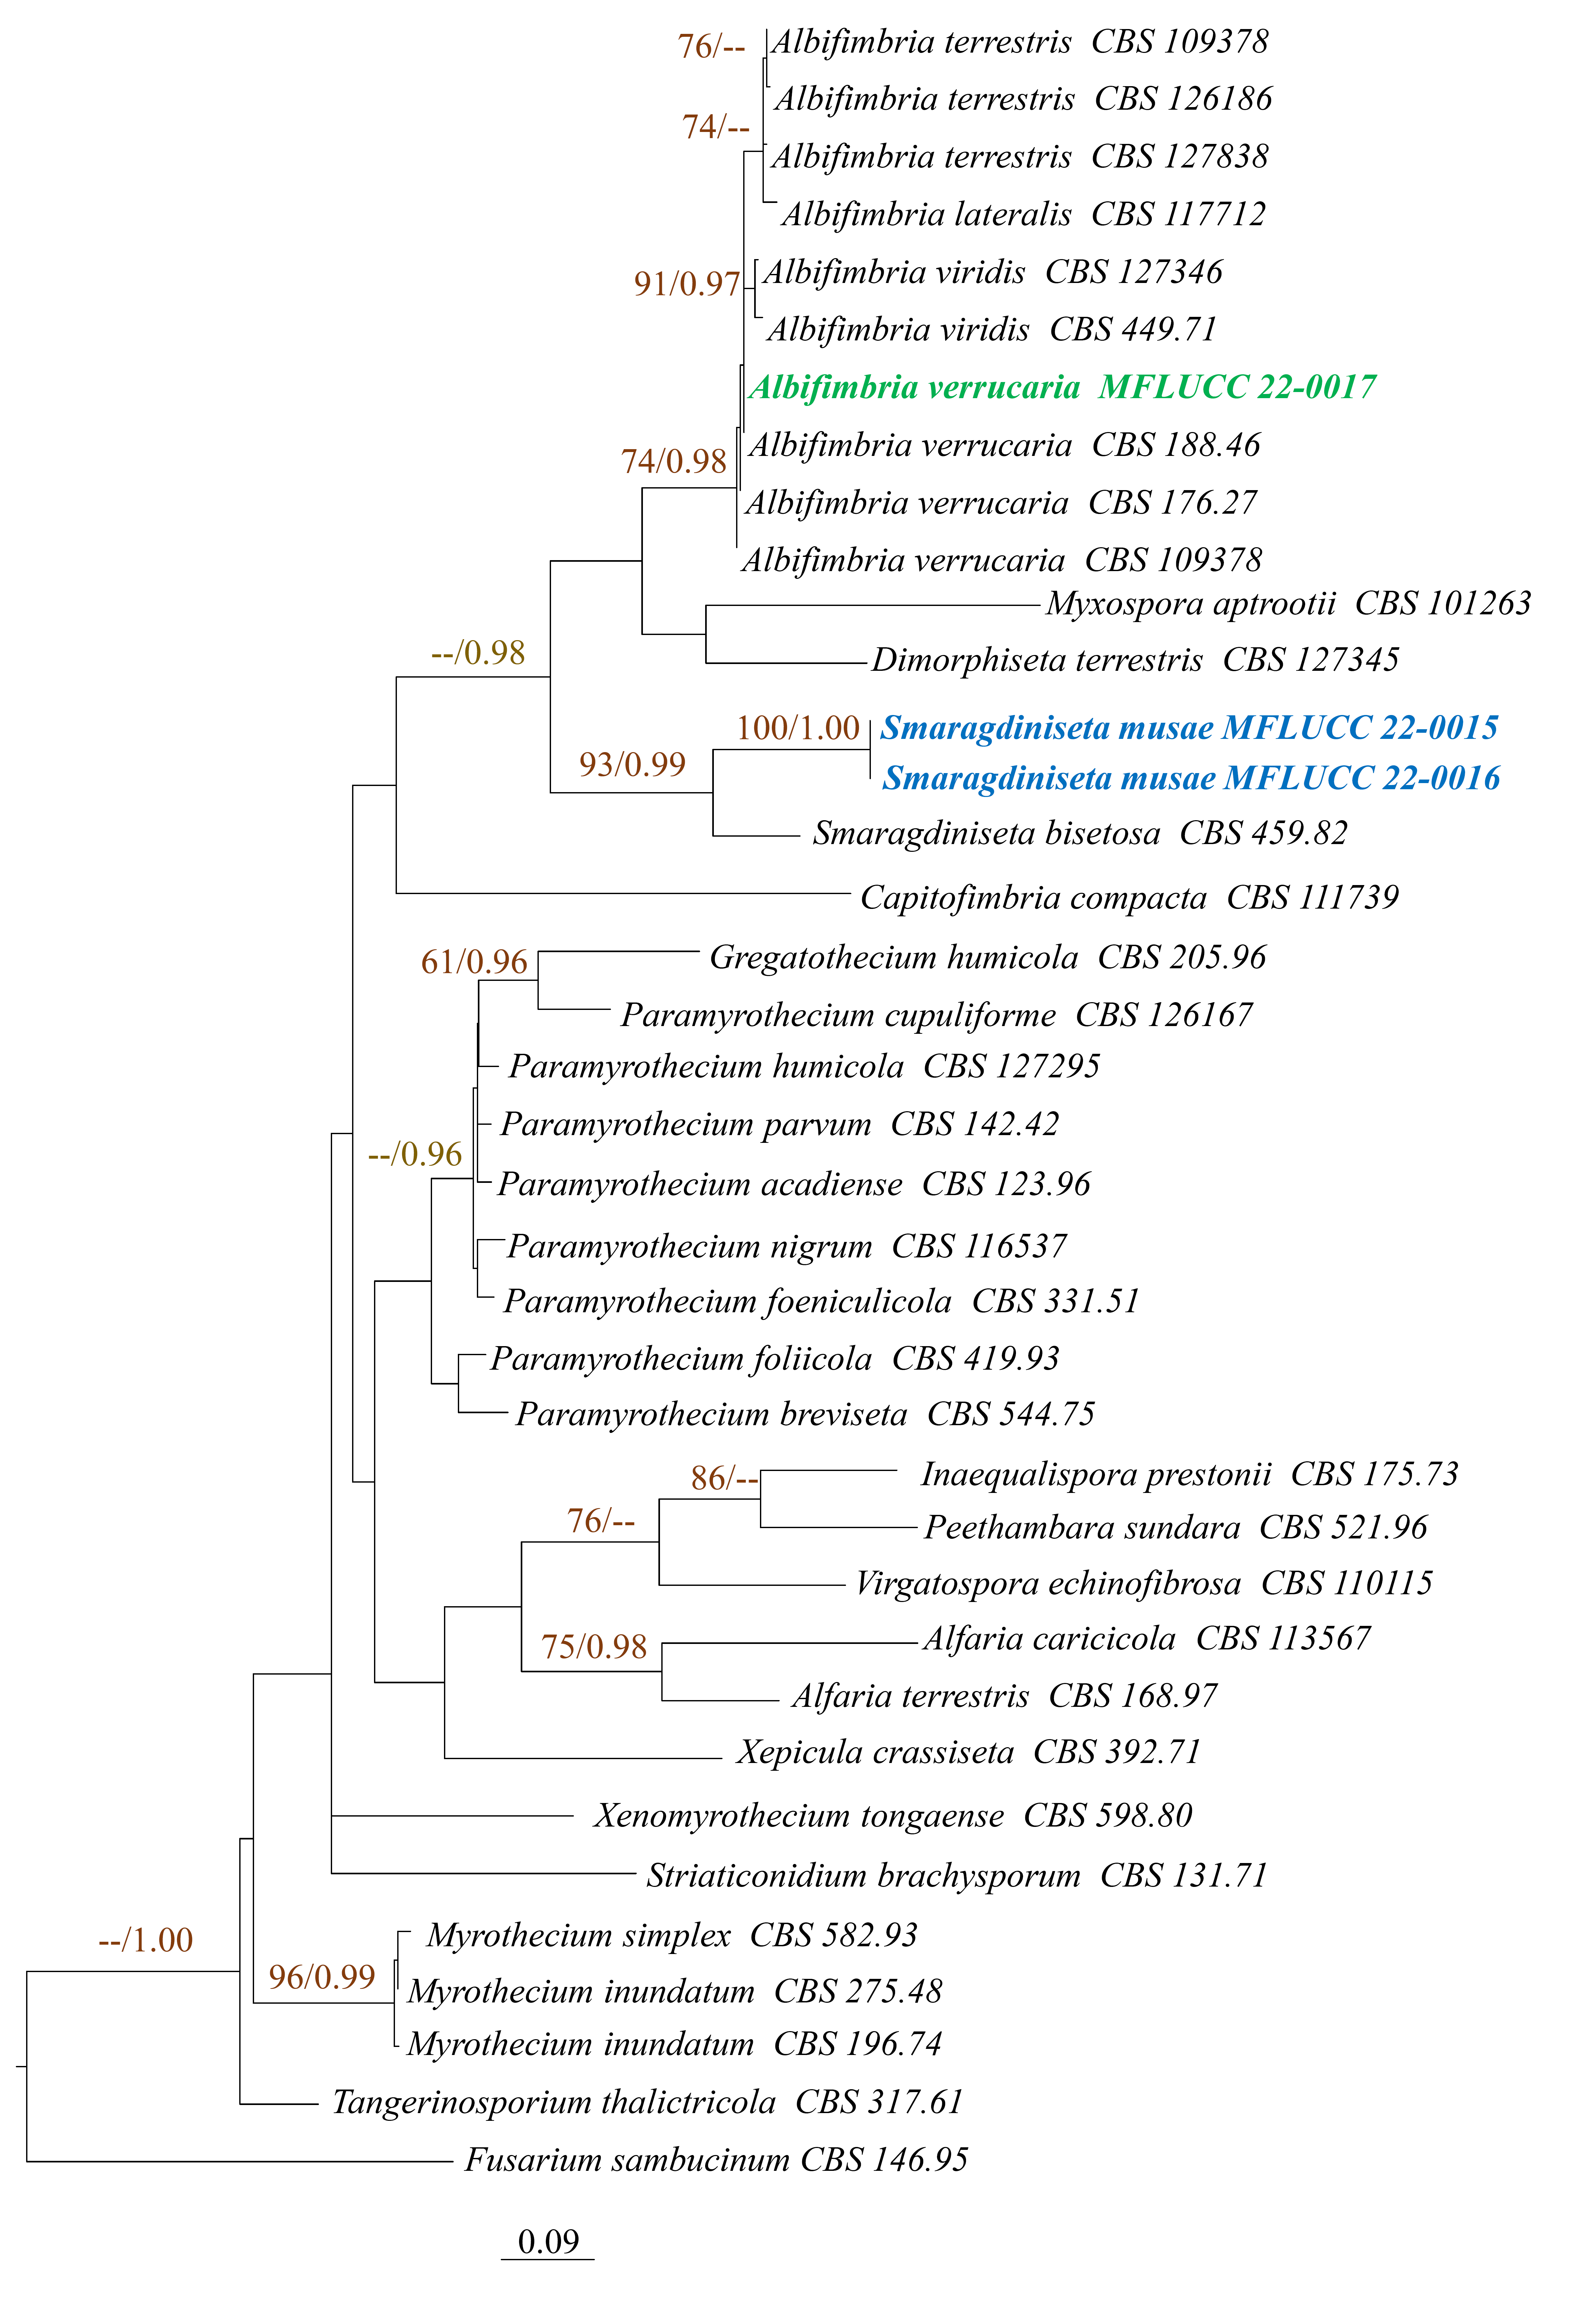
Figure 2. Maximum likelihood tree revealed by RAxML analyses of tub2 sequence data of selected genera of Stachybotryaceae, showing the phylogenetic position of Albifimbria verrucaria (MFLUCC 22-0017) and Smaragdiniseta musae (MFLUCC 22-0015, MFLUCC 22-0016). ML bootstrap supports (≥60%) and Bayesian posterior probabilities (≥0.95 BYPP) are given above the nodes, respectively. The tree is rooted with Fusarium sambucinum (CBS146.95) (Nectriaceae). The scale bar represents the expected number of nucleotide substitutions per site.

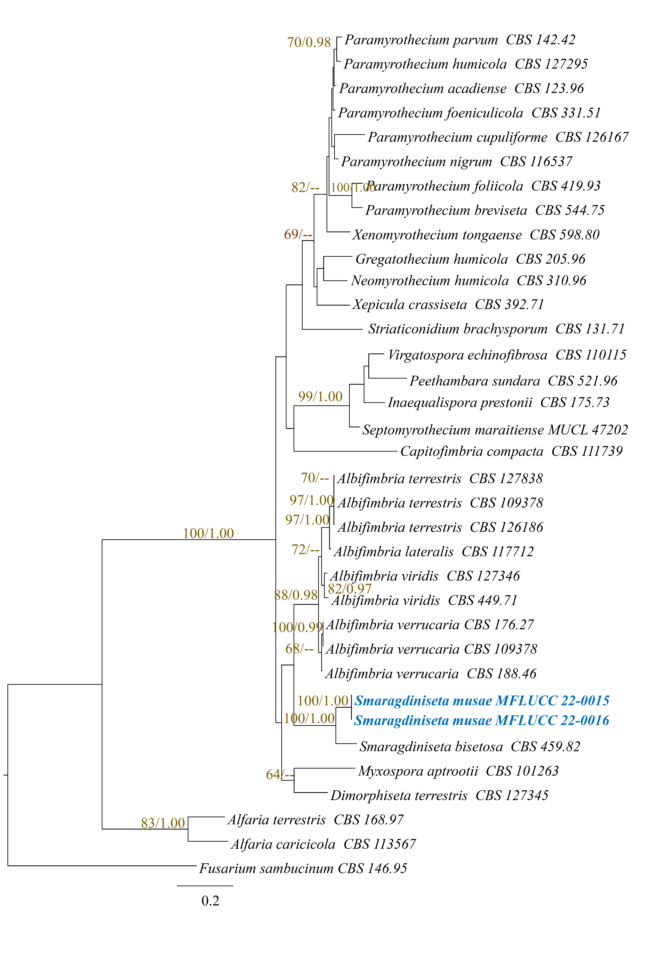

Figure 3. Maximum likelihood tree revealed by RAxML analyses of rpb2 sequence data of selected genera of Stachybotryaceae, showing the phylogenetic position of Albifimbria verrucaria (MFLUCC 22-0017) and Smaragdiniseta musae (MFLUCC 22-0015, MFLUCC 22-0016). ML bootstrap supports (≥60%) and Bayesian posterior probabilities (≥0.95 BYPP) are given above the nodes, respectively. The tree is rooted with Fusarium sambucinum (CBS146.95) (Nectriaceae). The scale bar represents the expected number of nucleotide substitutions per site.

